JAY PRAKASH PANDEY (IT_2ND YEAR, A-44)

12019002004044

Saurav Kumar (IT_2ND YEAR, A-48)

12019002004051

**ABSTRACT**

We are a social animal, which means we always wants be in group, friends and family. for social interaction we need to store details related to persons.

The collective of data structure is known as phonebook. For storing the data, we use c++ language because it is fast and object oriented. And the memory management in this project such that it works without any bug in low amount of storage taking care of devices having less storage.

**OBJECTIVES**

We are determined to design a system which is intended in saving name and number of desired persons. The main objective of telephone directory is to add, search, edit and delete various contacts.

# METHODOLOGY

A phonebook directory (also called a telephone book) is a listing of telephone subscribers in a geographical area or subscribers to services provided by the organization that publishes the directory. It consists of the name as well as the contact number of people added as contact in the directory. Name and contact number are displayed in alphabetical order.

**Description**

It is a friendly easy to use interface developed with data structure as the backend to store the details. This application stores all the details like name, telephone number and email id in a database. This system is developed to reduce the errors that creep up in manual systems. This software also allows to edit, update and search various contact details. It is secure, easy to use and reliable software system. It also provides a good level of security as there is an admin who can only edit and update details.

• Admin module: This is the main module where the administrator logins into the database. All the admin details are stored with user id.

• Create Contact module: This module allows the user to enter all the details like name, phone number and email id.

• Insert module: In this module, all the details regarding contacts are inserted.

• Delete module: In this module, the records with a specific id are deleted.

• Display module: This module allows the user to view all contact details.

• Search module: This module allows to search for the contact details by just entering its name.

**RESULT**

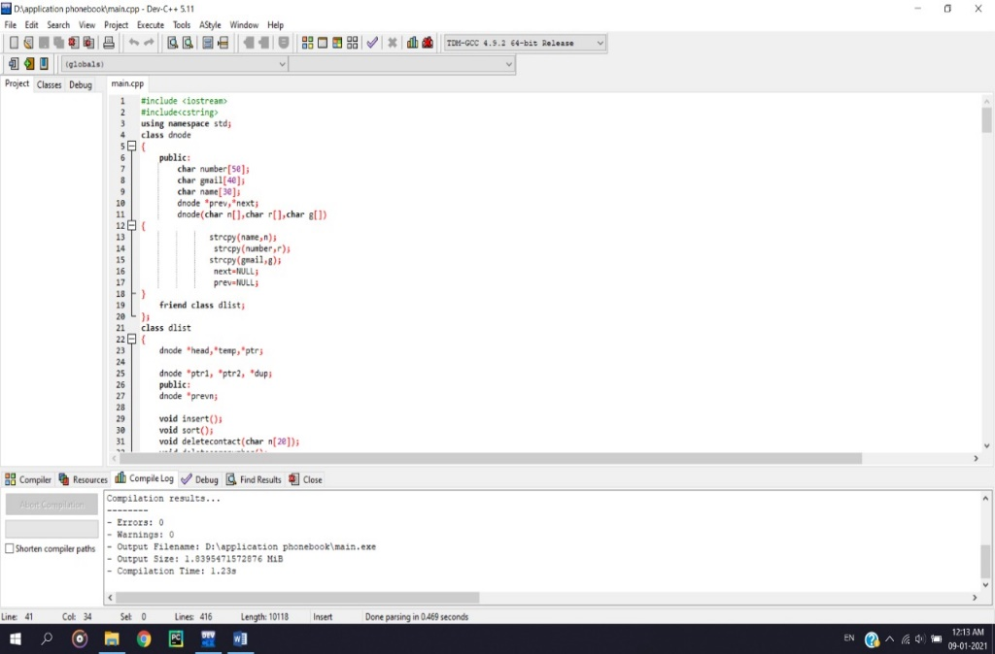

Abhishek Anand (IT_2ND YEAR, A-57)

12019002004061

Saurav Anand (IT_2ND YEAR, A-59)

12019002004064

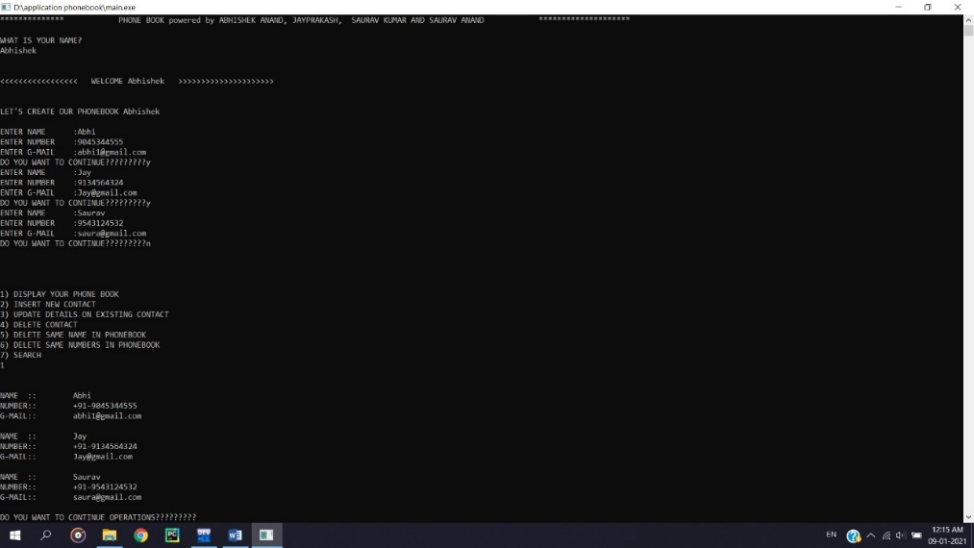

**CONCLUSION**

By implementing this program, we can execute the contact data, delete data, searching, updating, exit and display Numbers. For creating this application, we used arrays, pointer, structure and Doubly linked list. We have written the separate functions for all the operations that we can do in this application. We used C++ language for compilation of this program for the purpose of time and space complexity.

**REFERENCES**

[1] Mahalingam, A., R. T. Naayagi, and N. E. Mastorakis. "Data and management in c++” Recent Researches in Applications of Electrical and Computer Engineering, pp. 20-24, 2012.

[2] Attia, Hussain A., and Halah Y. Ali. "file and data with c++" International Journal of Applied Engineering Research, vol. 11, no. 19, pp. 9721-9726, 2016.

[3] Apeh, S. T., K. B. Erameh, and U. Iruansi. "Data in c++ and structures”Journal of Emerging Trends in Engineering and Applied Sciences, vol. 5, no. 3, pp. 222-228, 2014.

**Contacts**

[**mailto: JAY PRAKASH PANDEY**](mailto:jayprakashpandeya082@gmail.com)

[**mailto:ABHISHEK ANAND**](mailto:abhianand2308@gmail.com)

[**mailto:Saurav Kumar**](mailto:sauravkiul811310@gmail.com)

[**mailto:Saurav Anand**](mailto:sauravaanand700@gmail.com)